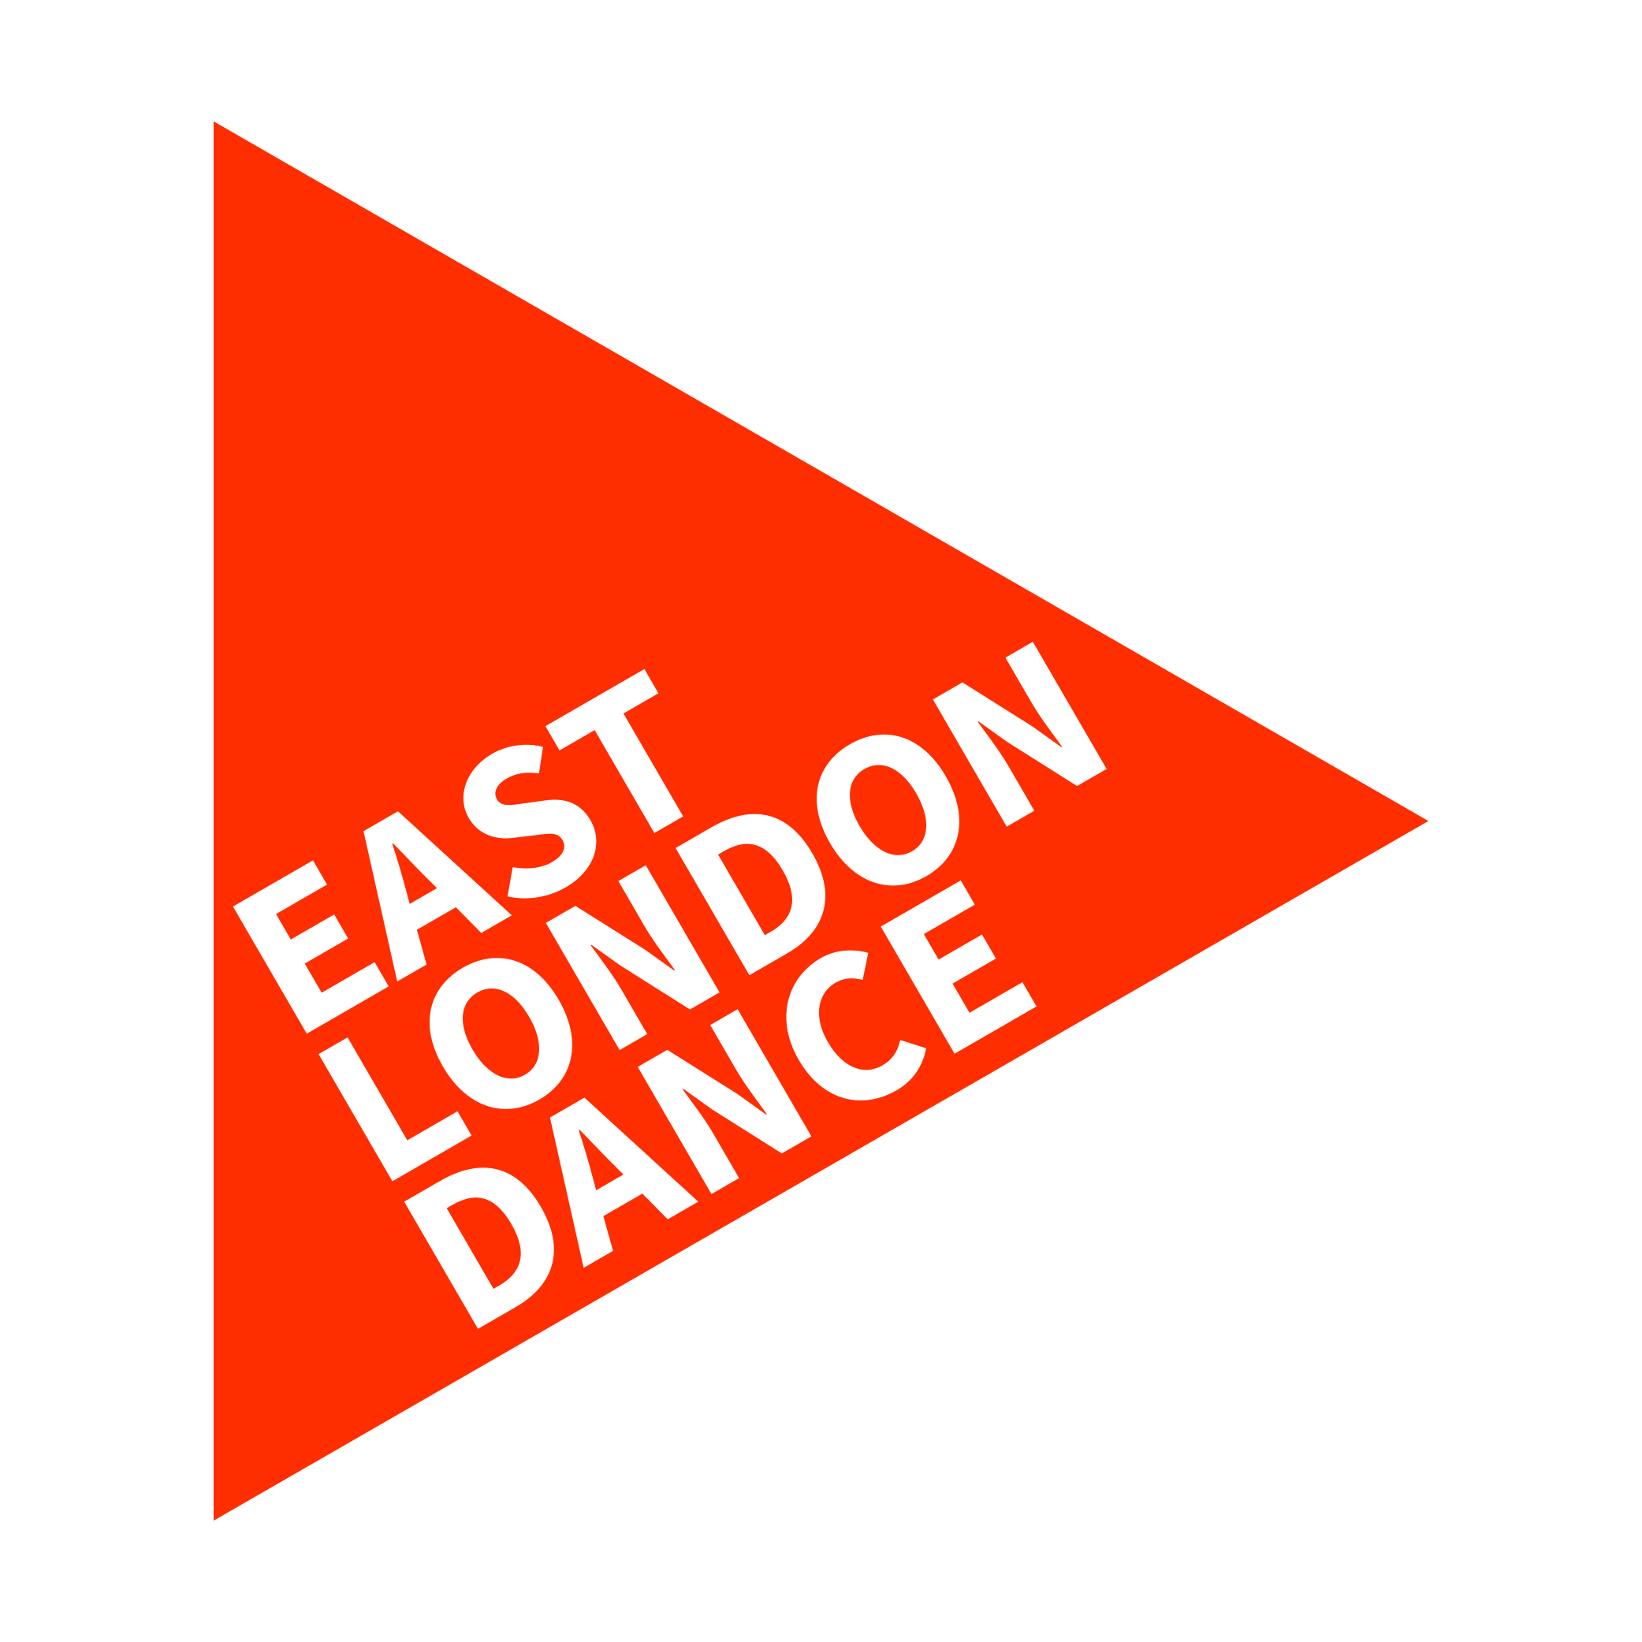

The Fi.ELD 2018 Application form

Instructions for submitting your application form

You can apply to join the Fi.ELD in two ways:
- In Writing. You can complete all the below questions in writing and email or post a copy to East London Dance (our email and postal address can be found at the bottom of page 4).
- By Video. Your answers to section 2 can be submitted by video but you will still need to complete section 1 and the equal opportunities at the bottom of the form in writing and send it to us via email (or post). Please submit your video via YouTube or Vimeo and include the url link and viewing password in the Question 1 box.
Alternatively, you can send us the video through WeTransfer, Dropbox or Google Drive but please indicate you will be doing this in the Question 1 box and again include any relevant links or passwords. If you are submitting your application by film please ensure:
  - Your video is private
  - You have sent us the relevant link or password to access it. We are expecting to receive lots of applications, so if you do not send us this information we will not be able to chase or remind you.
  - Your film is no longer than 4 minutes long.

The deadline to submit applications is Friday 13th October at 5pm

SECTION 1

Personal Details
Full Name
Company / Group Name (if applicable)
Address
Borough
Postcode
Telephone
Email
Date of Birth
Do you have any access requirements or additional support needs? If so let us know

Please give details of one referee.
Name
Your relationship to this person
Company
Their position
Address
Telephone
Email

How did you first hear about The Fi.ELD? | Social Media | Through a job or community centre
 | East London Dance newsletter,email or website | Through another arts organisation
 | Job/ Opportunity online listing | Through school or college
 | Word of Mouth | Other
 | If you were told about the project by another organisation, please tell us their name:
 | If ‘other’ please specify:

SECTION 2

Question 1
Tell us about yourself and why you want to join the Fi.ELD?
Please consider how this programme could develop your knowledge and skills, what motivates you and where you see yourself in the future professionally.

Question 2
What would you bring to the programme?
- Please discuss your opinions and ideas about the dance provision for children and young people.
- Have you identified a gap in the dance market? How you hope to fill the gap, what are your ideas and who will benefit from your plans?

Question 3
Give an example of when you have made (or helped make) something happen. It could be a project, class or event.
Please tell us about:
- the role you played
- what impact the activity had on its audience/participants/you

If you would like to talk to a member of the East London Dance team about your application, or need any technical support please contact Bryony Farrant-Davis on
bryony.farrant-davis@eastlondondance.org or call 020 8270 1052.

Please complete this application form and return to East London Dance by:
Friday 13th October, 5pm

You can email your application to bryony.farrant-davis@eastlondondance.org or post to:
Bryony Farrant-Davis, East London Dance, Stratford Circus, Theatre Square, London
E15 1BX

Group Interviews will be held on Saturday 11 November in Stratford.

Stay in Touch:

East London Dance regularly emails our audiences with opportunities, news, developments, information about our projects and other ways to get involved.

Would you like to be added to the East London Dance mailing list?

 Yes No
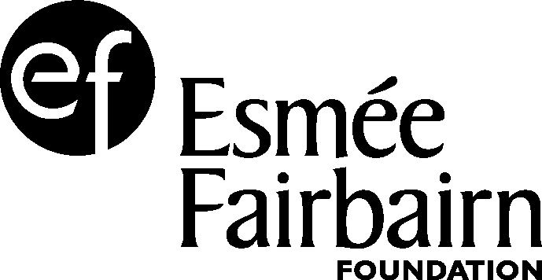

EQUAL OPPORTUNITIES MONITORING
East London Dance want to ensure this opportunity is accessible to all eligible participants. It will help us to monitor the effectiveness the application process if you could supply the following information. The information on this form will be used anonymously for statistical monitoring only and will have no bearing on your application.

Nationality
Gender
Do you consider yourself to have a disability as defined by the Equality Act 2010? | Yes |  | No

Ethnic Origin (please tick the box which most closely relates to you):

Asian or Asian British | Bangladeshi | Indian
 | Pakistani | Other Asian background
 | If ‘other’ please specify:
Black or Black British | African | Caribbean
 | Other black backgrounds | If ‘other’ please specify:
Chinese or other Ethnic Group | Chinese | Other ethnic group  If ‘other’ please specify:
Mixed | White and Asian | White and Black African
 | White and Black Caribbean | Other mixed background  0
 | If ‘other’ please specify:
White | British | Irish  0
 | Other white background
 | If ‘other’ please specify:

Which of the following best describes your employment status?
In full-time education | Employed – full-time | Employed – part-time
Not currently employed but looking for work | Self employed | Retired
Other, please specify: ___________________________________________________________

