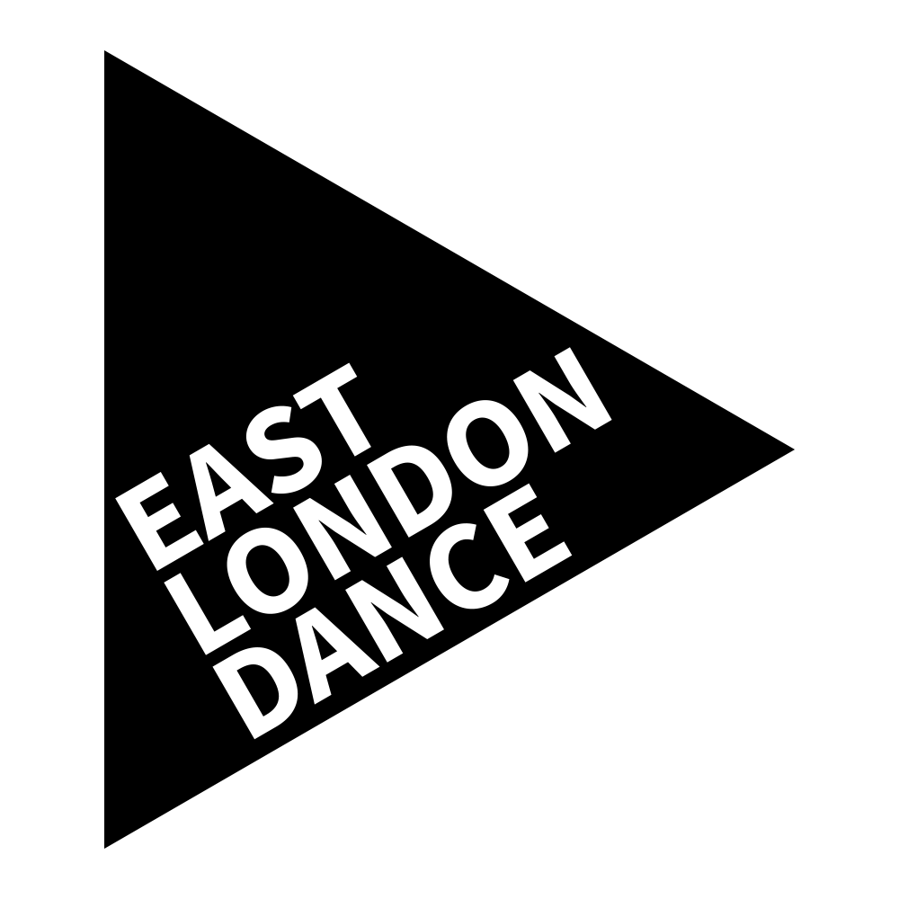
Dance Enterprise Ideas Fund
Application Form
Part of the Dance Enterprise Hub
Deadline: 10am, Monday 20 February 2017

Funding and support to help your creative idea become a reality

Sections 3, 5 & 6 can be answered via video submission, but if doing so you must still complete sections 1, 2 & 4 on the form in full. See application guidelines for full details.

1. Personal Details
First Name
Surname
Name of Company
(if relevant)
Address

Post Code
Telephone
Email
Do you wish to join the East London Dance mailing list?
Do you have any access requirements or additional support needs?
If yes, please specify
2. Availability check
If selected you will have the opportunity to meet the Dance Enterprise Summit Facilitators Anamaria Wills and Jeanefer Jean Charles to discuss your pitch. This is a valuable opportunity to sound out your proposal and receive feedback in preparation for the pitch at The Dance Enterprise Summit.

Please identify your top 3 preferences out of the following days for this to take place. Mark using a 1 for your most preferred and 3 as your least preferred and pencil all three in your diary.
Monday 6 March |  | AM |  | PM
Wednesday 8 March |  | AM |  | PM
Thursday 9 March |  | AM |  | PM
Friday 10 March |  | AM |  | PM
Monday 13 March |  | AM |  | PM
Wednesday 15 March |  | AM |  | PM
Thursday 16 March |  | AM |  | PM
Friday 17 March |  | AM |  | PM
All pitches will be made to a panel of industry professionals in front of a live audience at the Dance Enterprise Ideas Summit on Friday 31 March 2017. If you are not available for this date you are not eligible to apply for the fund. Please sign to agree that you are available below:
I confirm I am available on Friday 31 March 2017

3. Your Idea

Please describe your idea (max 500 words)
Think about the 5Ws: who, what, when, where, why. Include your vision, who is involved, who will benefit, what impact or change you want to achieve and your timeline. Please refer to the Application Guidelines for guidance.
What stage of development is this idea at? How will you use the Dance Enterprise Ideas Fund to research, test or launch this idea? (max 300 words)
Please include timescales and refer to the Application Guidelines. Please note the money must be spent by March 2018.
What is your long-term vision for the idea? How might you fund and resource the idea? (max 250 words)
4. Budget
How much are you pitching for? (maximum £5,000)
How do you plan to spend this money?
Item Description | Breakdown of Costs | Cost
GRAND TOTAL COST
Do you have any financial or in-kind support in place already? If so, who and how much?
NB. It is not a requirement to have match funding in place
5. What other additional support and advice do you need from East London Dance and partner organisations to help you launch your idea? (max 300 words)

6. About You
Tell us about yourself and your work (max 300 words)
Please provide us with your Twitter, YouTube and Instagram names
Please provide website or video links that are relevant to your application below:

Please complete this application form and email your application to office@eastlondondance.org by
10am on Monday 20 February 2017

If you have any questions please contact East London Dance on
020 8279 1050

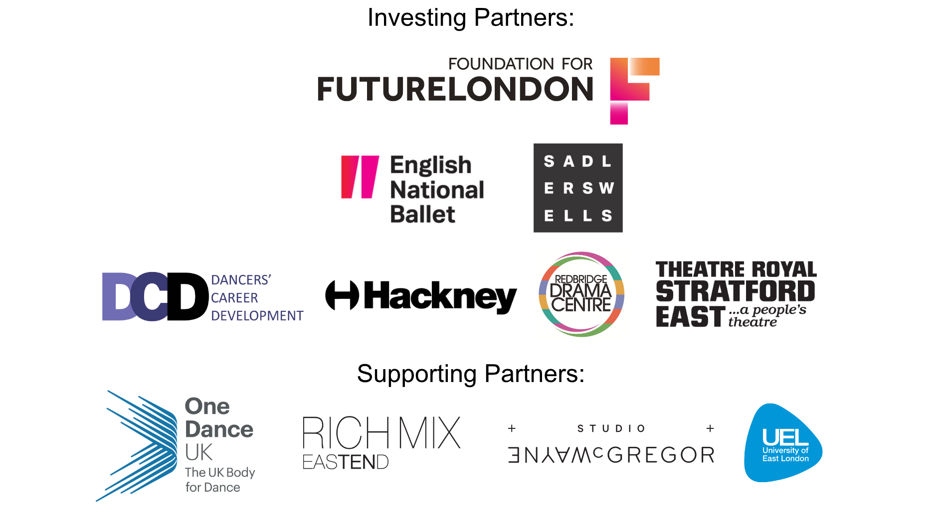

EQUAL OPPORTUNITIES MONITORING
East London Dance want to ensure this opportunity is accessible to all eligible participants. It will help us to monitor the effectiveness the application process if you could supply the following information. The information on this form will be used anonymously for statistical monitoring only and will have no bearing on your application.

Nationality
Do you consider yourself to have a disability as defined by the Equality Act 2010? | Yes |  | No
Gender | Male |  | Female
Date of Birth

Ethnic Origin (please tick the box which most closely relates to you)

Asian or Asian British: | Bangladeshi: |  | Indian:
 | Pakistani: |  | Other Asian background:
 | If ‘Other’ please specify:
Black or Black British: | African: |  | Caribbean
 | Other black backgrounds:
 | If ‘Other’ please specify:
Chinese or Other Ethnic Group | Chinese |  | Other ethnic group
 | If ‘Other’ please specify:
Mixed: | White and Asian: |  | White and Black African:
 | White and Black Caribbean: |  | Other mixed background
 | If ‘Other’ please specify:
White | British: |  | Irish:
 | Other white background:
 | If ‘Other’ please specify:

