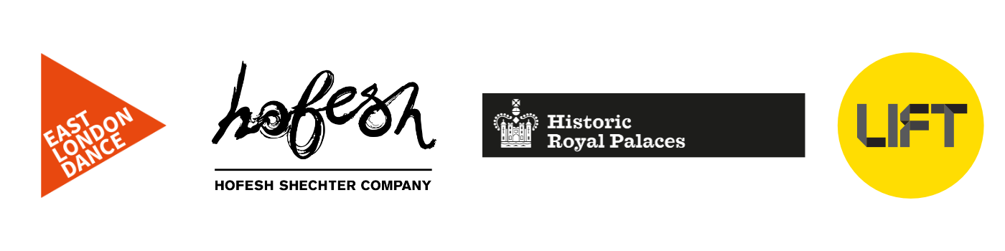East Wall Community Cast

Performers Application Form

Any information given is strictly confidential but may be securely stored digitally and used anonymously in the monitoring, evaluation and statistical reporting of East London Dance, Hofesh Shechter Company, Histotic Royal Palaces and LIFT’s and work.

Group Details
Group Name
Group Leader Name
(As group leader you will act as main point of contact for your group)
Email
Telephone
Number of group members
(ideally minimum 10 - maximum 30)
Please list ages of group members
(ages 13-25)
Please indicate your Group’s weekly rehearsal schedule | DAY:  TIME:
Address of group’s rehearsal space

Please tell us about the group and the style of movement
Please let us know if there are any access requirements or additional needs for your group
Availability
To be elegiable for this opportunity, the group needs to be available for ALL dates listed below.

Dates (S) | Session Titles | Availability
10 March 2018 | Open Day
7 & 8 April 2018 | 2-day Spring Intensives
April – June 2018  ( w/c 9 April- w/c 18 June) | Weekly Rehearsals
May half term 2018  31 May, 1 & 2 June | 3-day half term intensive
w/c 25 June 2018 | Full cast rehearsals (part time commitment)
w/c 2 July 2018 | Full cast rehearsals (part time commitment)
w/c 9 July 2018 | Full cast rehearsals and production week (part time commitment)
w/c 16 July 2018 | Full time performance week (5 x evening performances)

Your Application
You may submit this section by answering the questions in writing or to camera and submitting a web-link (Vimeo or YouTube only). If you chose to film your answers we need to be able to see and hear you clearly (filming yourself on your phone is fine).
You have a maximum of 150 words for each question for a written entry and a maximum of 1.5 minutes on video per question. (If you do submit a film please copy one single link into the relevant box below. The total length of the film should be no longer than 4.5 minutes).
Please detail why your group would like to take part in this opportunity? (150 words)

Please indicate how you would ensure commitment of the group members for the duration of this opportunity? (150 words)

Please list any other performance opportunities your group have been part of?

If you have any video links of the group’s work you’d like to share with us please share them here.

Please complete this application form and return to East London Dance by
10am Friday 2 February 2018

By email:office@eastlondondance.org : REF EAST WALL OPEN DAY APPLICATION
By post: East London Dance
Stratford Circus Arts Centre
Theatre Sqaure
E15 1BX

If you have any queries or difficulty completing the application form, please contact office@eastlondondance.org or 020 8279 1050

Please tick the box below if you would like to receive information about future classes, performances, opportunities and developments from East London Dance

I would like to join East London Dance’s emailing list

EQUAL OPPORTUNITIES MONITORING
East London Dance and the East Wall Project Partners want to ensure this opportunity is accessible to all eligible participants. It will help us to monitor the effectiveness the application process if you could supply the following information about the person filling this application in. The information on this form will be used anonymously for statistical monitoring only and will have no bearing on your application.

Nationality
Gender
Do you consider yourself to have a disability as defined by the Equality Act 2010? | Yes |  | No

Ethnic Origin (please tick the box which most closely relates to you)

Asian or Asian British: | Bangladeshi: |  | Indian:
 | Pakistani: |  | Other Asian background:
 | If ‘Other’ please specify:
Black or Black British: | African: |  | Caribbean
 | Other black backgrounds:
 | If ‘Other’ please specify:
Chinese or Other Ethnic Group | Chinese |  | Other ethnic group
 | If ‘Other’ please specify:
Mixed: | White and Asian: |  | White and Black African:
 | White and Black Caribbean: |  | Other mixed background
 | If ‘Other’ please specify:
White | British: |  | Irish:
 | Other white background:
 | If ‘Other’ please specify:

